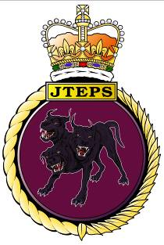 |  | Joint Tactical Exercise Planning Staff  Northwood Headquarters  Sandy Lane  NORTHWOOD  Middlesex  HA6 3HP  BT: (01923) 958788  Fax: (01923) 958779  E-mail: jteps-sm-so2@mod.uk
 |  | 11 July 2017

EXERCISE SAXON WARRIOR 17 SUBMARINE AND LIVE FIRING TRAINING ACTIVITY

1. Exercise SAXON WARRIOR 17 (SW17) will take place between 1 and 10 August 2017, delivered by the Joint Tactical Exercise Planning Staff (JTEPS) from Faslane. The coordination of the administration and safety will be arranged in a similar way to a JOINT WARRIOR exercise. SW17 is a programme of exercises conducted across the UK by warships, submarines and aircraft from 5 Nations. The maritime and air activity will be focussed in the airspace, offshore and coastal waters of the whole coast of Scotland and to a lesser extent South West Approaches to the UK. This booklet provides outline information on scheduled activity including details of intended gunnery and aircraft bombing activity at Cape Wrath.
2. This information is correct at the time of print but the routine SUBFACTS and GUNFACTS broadcasts, made during the exercise, will provide updated information.
3. The information provided in this booklet will also be published in Fleet Ops Notice to Fishermen, Defence Training Estate Scotland Notice to Fishermen, Cape Wrath Range Notices and Notices to Airmen. This document can also be accessed via the internet at:
http://www.royalnavy.mod.uk/qhm/clyde/jw.

4. This booklet contains the following sections:

a. Submarine Activity.

b. Warship and Aircraft Activity.

c. Live Firing and Gunnery Activity.

d. Unexploded Ordnance Advice.

5. Warships taking part have been instructed to offer fishing vessels and the wider civilian community every assistance in their dealings with exercise activity. This applies especially when in the vicinity of submarines, when warships are conducting live firing. You are invited to contact them via VHF to ensure and military training and civilian activities are safely de-conflicted.

6. There will be no minesweeping or minehunting activity during the exercise.

7. There will be no denial of GPS services through the jamming of the GPS signal.

8. Throughout SW17 the following points of contact are available on a 24/7 basis to address any immediate problems or questions:

Primary - Saxon Warrior Duty Controller 01436 674321 Option 1 Ext 3401

Secondary - Duty Submarine Controller 01923 956366

HM Coastguard at Belfast, Stornoway and Aberdeen can also contact the SW17 staff directly and will relay information if necessary.

9. If you have any queries, problems, or suggestions as to how JTEPS can improve this booklet, please do not hesitate to contact the Joint Tactical Exercise Planning Staff at the above address.

Signed on Dii

A M Stacey
Captain Royal Navy
Captain JTEPS

1. The Submarine Activity Grid on the following page shows the forecast areas and time periods of submarine activity associated with Saxon Warrior 17 (SW17). Please note that other submarines that are not part of the exercise may transit the areas north west of Scotland; their activity is not covered in this brief. The daily SUBFACTS broadcast by the Coastguard will provide notification of the actual areas where exercise and transiting submarine activity is taking place.

2. Communications can be established with submarines during SW17 when they are surfaced or at periscope depth on VHF Ch 16 (working Ch 73). In the event that they are operating with warships, one of the warships will have been detailed to act as the Fishing Vessel Safety Ship (FVSS) in accordance with the Code of Practice. The FVSS has two overarching duties:

a. To make fishing vessels aware of submarine activity in their vicinity and to provide information and advice to minimise the risk of interaction.

b. To provide assistance to the participating submarine in compiling a comprehensive surface picture in order to minimise the risk of interaction with non-exercise vessels.

3. It is usually easier to establish communications with the FVSS than with a submarine. However, any warship in the vicinity may be contacted and asked for a report on any exercises involving submarines which are being conducted in the local area. Alternatively, the ship may be used to relay messages or instructions to the submarine if required. All warships, including the FVSS, can be contacted on VHF Channel 16 (working Channel 73).

4. If any difficulty is experienced a call should be made to the Duty Submarine Controller at CTF 311 OPS ROOM on the “Fishermen’s Hotline” number: 01923 956366. This line is permanently manned.

EXERCISE SAXON WARRIOR 17 SUBFACTS AREAS ACTIVATION GRID, ALL TIMES IN LOCAL (BST)

 | 1 AUG |  |  | 2 AUG |  |  | 3 AUG |  |  | 4 AUG |  |  | 5 AUG |  |  | 6 AUG |  |  | 7 AUG |  |  | 8 AUG |  |  | 9 AUG |  |  | 10 AUG
 | TUE |  |  | WED |  |  | THU |  |  | FRI |  |  | SAT |  |  | SUN |  |  | MON |  |  | TUE |  |  | WED |  |  | THU
Active Time Period BST | 0001 - 0800 | 0800 - 1600 | 1600 - 2359 | 0001 - 0800 | 0800 - 1600 | 1600 - 2359 | 0001 - 0800 | 0800 - 1600 | 1600 - 2359 | 0001 - 0800 | 0800 - 1600 | 1600 - 2359 | 0001 - 0800 | 0800 - 1600 | 1600 - 2359 | 0001 - 0800 | 0800 - 1600 | 1600 - 2359 | 0001 - 0800 | 0800 - 1600 | 1600 - 2359 | 0001 - 0800 | 0800 - 1600 | 1600 - 2359 | 0001 - 0800 | 0800 - 1600 | 1600 - 2359 | 0001 - 0800 | 0800 - 1600 | 1600 - 2359
ORSAY
N.CHANNEL
HEBRIDES |  |  | A | A | A | A | A | A | A | A | A | A | A | A
MINCH |  |  |  |  |  |  |  | A | A | A | A | A | A | A | A | A | A | A | A | A | A | A | A | A | A | A | A | A | A | A
UIST |  |  |  |  |  | A | A | A | A | A | A | A | A | A | A | A | A | A | A | A | A | A
LEWIS |  |  |  |  |  |  |  | A | A | A | A | A | A | A | A | A | A | A | A | A | A | A | A | A
PENTLAND |  |  |  |  |  |  |  |  |  |  | A | A | A | A | A | A | A | A | A | A | A | A | A | A | A | A | A | A | A | A
SKERRY |  |  |  |  |  |  |  |  |  |  |  |  | A | A | A | A | A | A | A | A | A | A | A | A
DEEP 1 |  |  |  |  |  |  |  |  |  |  |  |  | A | A | A | A | A | A | A | A | A | A
DEEP 2 |  |  |  |  |  |  |  | A | A | A | A | A | A | A | A | A | A | A | A | A | A | A | A | A | A
DEEP 3 |  |  |  |  |  | A | A | A | A | A | A | A | A | A | A | A | A | A | A | A | A
SHETLAND
MORAY |  |  |  |  |  |  |  |  |  |  |  |  |  |  |  |  |  |  |  |  |  |  |  | A | A | A | A | A | A | A
FORTH

The planned activity in the SW SUBFACTS AREAS is indicated by the letter A in the grid above.
There may be changes to this planned activity.
Daily SUBFACTS Broadcasts will contain the most up to date information regarding the activation of the areas.
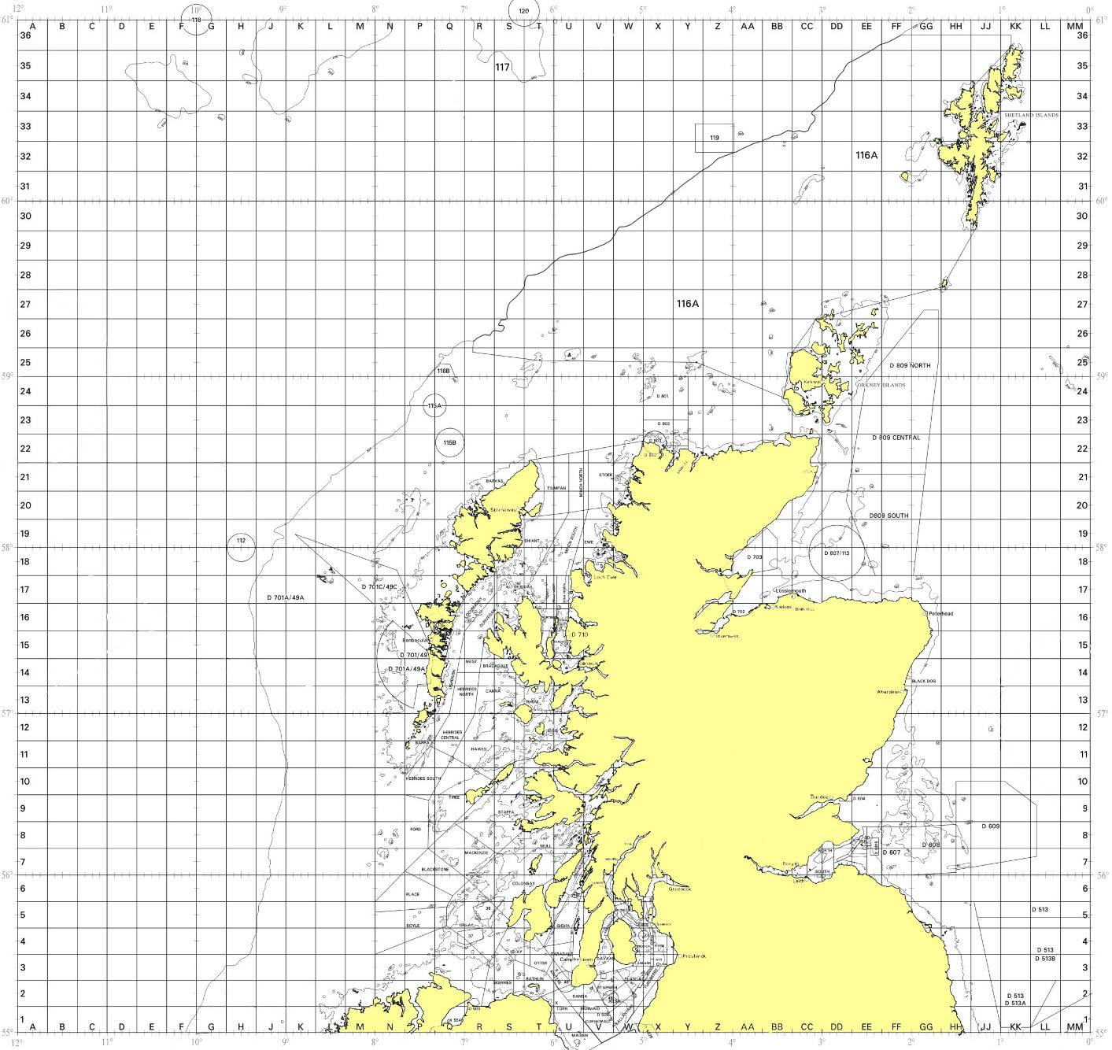
Deep 2
Deep 1
Deep 3
Skerry
Moray
Forth
Pentland
Lewis
Uist
Minch
Hebrides
North
Channel
Shetland
55 N
59 N
60 N
58 N
56 N
57 N
61 N
12 W
10 W
08 W
02 W
06 W
04 W
Orsay
SW17 SUBFACTS
Area Groupings

VHF Challenges

1. In light of ever changing threats to our Armed Forces, military ships maintain a detailed plot of maritime activity in their vicinity, which includes establishing the identity of small fishing vessels. This can be achieved visually from helicopters or by challenges on IMM VHF radio by ships. Mariners are advised that warships from various Allied Nations will be conducting such reconnaissance and challenges. Areas likely to be affected are the South West Approaches to UK and around Scotland concentrated on the North Channel, South of the Sea of Hebrides, the Sea of Hebrides, the Little Minch, North Minch, the area near Cape Wrath, Loch Eriboll, the Outer Hebrides and in the North Sea near Wick. Mariners’ co-operation during this time would be much appreciated. A small number of contracted civilian vessels including high speed craft will be operating in the vicinity of the Minches in support of this training task. Every effort will be made to avoid interference to fishing vessels.

Fixed Flying Operations

2. An aircraft carrier will take part in the exercise. Mariners are requested to remain clear of the aircraft carrier during the periods when it is launching and recovering aircraft. The vessel will display Restricted in Ability to Manoeuvre shapes and /or lights during these operations.

Illumination of Aircraft

3. SW17 will involve a large number of aircraft. There have been instances during previous exercises where aircraft operating at low level over the sea have been illuminated by powerful searchlights from fishing vessels. Mariners are reminded that the deliberate and malicious targeting of airborne aircraft has the potential to impact upon aircraft safety and could lead to civil prosecution. Airman will report all illuminations to the coastguard and Civil Aviation Authority for further action to be taken against any spotlighting incidents.

1. During Saxon Warrior 17 (SW17), Cape Wrath Range, including Garvie Island (An Garbh-eilean) will be active with various combinations of air bombardment, naval gunfire support and helicopter operations. The GUNFACTS Activation Grid on the following page shows the areas and time periods where gunnery associated with SW17 is forecast to take place. The daily GUNFACTS Broadcast by the Coastguard and Cape Wrath Range will provide the latest information of the areas where gunnery activity is taking place.

2. It is mandatory that vessels in the vicinity of the Cape Wrath Range keep a listening watch on VHF Channel 16. Further information regarding firing at can be obtained by telephoning:

Cape Wrath Information Line on
FREEPHONE 0800 833300

or 01862 892185

The number will provide specific information about active/non-active periods and when the Range road (U70) will be open/closed for public access.

Exercise Saxon Warrior 17

FORECAST GUNFACTS AND SW17 OFFSHORE FIRING AREAS ACTIVATION GRID, ALL TIMES IN LOCAL (BST)

 | 1 AUG | 2 AUG | 3 AUG | 4 AUG | 5 AUG | 6 AUG | 7 AUG | 8 AUG | 9 AUG | 10 AUG
 | TUE | WED | THU | FRI | SAT | SUN | MON | TUE | WED | THU
Cape Wrath Range (Ashore) |  |  |  | 0001-2359 | 0001-2359 |  | 0001-2359 | 0001-2359 | 0001-2359
Cape Wrath D801 |  |  |  | 0700-2359 | 0700-2359 |  | 0700-2359 | 0700-2359 | 0700-2359
Cape Wrath D802 |  |  |  | 0700-2359 | 0700-2359 |  | 0700-2359 | 0700-2359 | 0700-2359
Garvie Island D803 |  |  |  | 0700-2359 | 0700-2359 |  | 0700-2359 | 0700-2359 | 0700-2359
- 0
The planned times of firings at Cape Wrath Range and SW17 Firing areas is indicated in the grid above. There may be changes to this planned activity. Daily GUNFACTS Broadcasts and Cape Wrath Range Broadcasts will contain the most up to date information regarding the activation of the areas. Times are Local.

1. The following general advice is offered to anyone discovering anything believed to be unexploded ordnance:

DIVERS DO NOT TOUCH

FISHERMEN Contact the coastguard. If this is not possible, lay the item
in about 60ft of water, away from shipping routes and mark
the position with a float.

EVERYONE DO NOT TOUCH – dial 999 for coastguard or Police.

Contact Telephone Numbers

UNEXPLODED ORDNANCE (FLEET DUTY CONTROLLER) 01923 956367

FISHERMANS’ HOTLINE (FLEET DUTY CONTROLLER)
SUBMARINE RELATED 01923 956366

SAXON WARRIOR 17 CONTROLLER 01436 674321 Ext 3401

CAPE WRATH INFORMATION LINE FREEPHONE 0800 833300

Joint Tactical Exercise Planning Staff, NCC Room 232, Northwood Headquarters,
Sandy Lane, NORTHWOOD, Middlesex HA6 3HP

E-Mail: JTEPS-SM-SO2@mod.uk

